Carrier Sense Multiple Access (CSMA) - Part 1

1. Carrier sense protocol
2. To **minimize** the chance of **collision** and therefore **increase the performance** the CSMA method was developed
3. Principle of CSMA: “”**Sense before transmit**” or “**listen before talk**”
4. Carrier busy = Transmission is taking place
5. Carrier idle = No transmission currently taking place.
6. The possibility of **collision still exists because of propagation delay**; a station may sense the medium and find it idle, only because the first bit sent by another station has not yet been received.
7. Types:
   1. 1-Presistent CSMA
   2. P-Persistent CSMA
   3. Non-Persistent CSMA
   4. O-Persistent CSAM
8. Modified protocols:
   1. CSMA/CD (CSMA with Collision Detection)
   2. CSMA/CA (CSMA with Collision Avoidance)

**1-Persistent CSMA**

1. Before sending the data, the station first listens to the channel to see if anyone else is transmitting the data at that moment.
2. If the channel is idle, the station transmits a frame.
3. If busy, then it senses the transmission medium continuously until it becomes idle
4. Since the station transmits the frame with the probability of 1 when the carrier or channel is idle, this scheme of CSMA is called as 1-Persistent CSMA.
5. The longer the propagation delay, the more important this effect becomes and the worst the performance of the protocol.

**Non-Persistent CSMA**

1. Before sending, a station senses the channel. If no one else is sending, the station begins doing so itself.
2. However, if the channel is already in use, the stat,on does not continually sense it for the purpose of seizing it immediately upon detecting the end of the previous transmission
3. Instead, it waits a random period of time and then repeats the algorithm. Consequently this algorithm leads to better channel utilization but longer delays than 1-persistent CSMA.

**P-Persistent CSMA**

1. It applies to slotted channels
2. When a station becomes ready to send, it senses the channel.
3. If it is idle, it transmits with a probability of P.
4. With a probability Q=1-P, it defers until the next slot.
5. If that slot is also idle, it either trransmits or defers again, with probabilities P and Q.
6. This process is repeated until either the frame has been transmitted or another station has begun transmitting.
7. In the latter case, the unlucky station acts as if there had been a collision (It waits a random time and starts again).
8. If the station initially senses the channel busty, it waits until the next slot and applies the above algorithm.

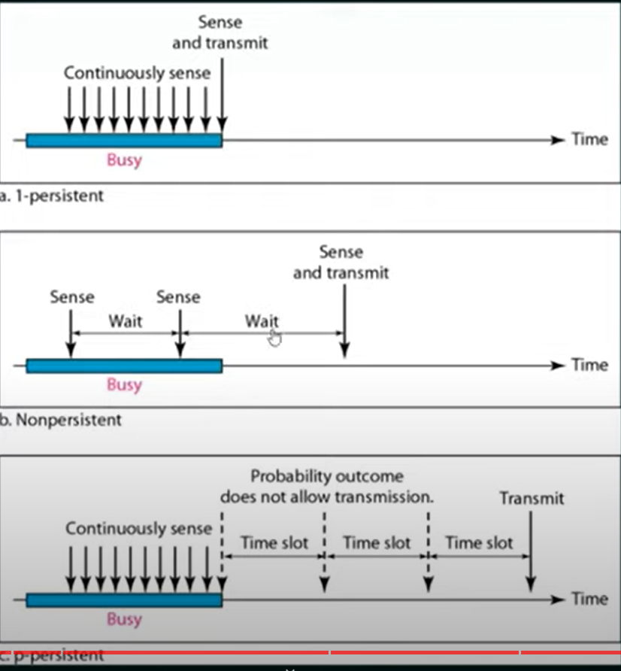

**P-Persistent CSMA**

1. Each node is assigned a transmission order by a supervisory node.